Alexander Mekovsky

COSC 320

Enyue Lu

3/9/2023

Lab Report: I have completed nearly all of the tasks required for this lab. While I was able to display each variable’s counts for the run, I was unable to display them with the tree. This is what my output looks like:
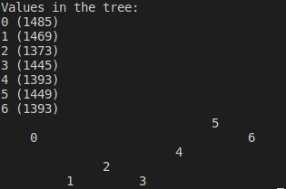

I do not know why the tree does not show the count next to each value, but other than this error everything else works fine. In regards to my header files, I have not changed any code that relates to the header files, and I have included my int.h file within the materials I turned in. The error could lie within the int.h file, although I am unsure. Overall this lab took me around two and a half hours to complete. Other than the error listed above, I have had no major issues with the code itself, although the placement of the “d_stiter.h” file did perplex me at first, I realized I should not have included it in my main.

